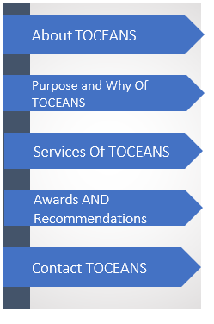**MAIN TOCEANS WEBSITE PAGE --- Pag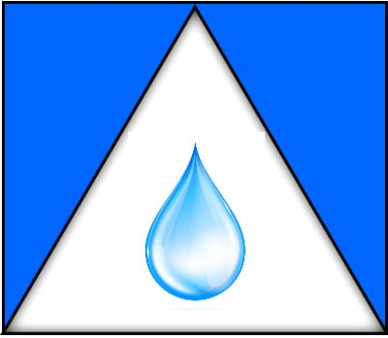****e**

|  |
| --- |
|  |

**MAIN TOCEANS WEBSITE PAGE --- Page**

**EDITED**

About TOCEANS

The Philosophy Of TOCEANS

The “Why” and “Purpose” Of TOCEANS

Services Of TOCEANS

Awards AND Recommendations

Contact TOCEANS

**PHILOSOPHY** **of TOCEANS --------Page**

**TOCEANS creativity and differential insight, works with you or your team, to Embryonic your potential, It`s Now!!!!!!!:**

**TOCEANS passionately believes we are limited by the items, situation, circumstances that we allowed to bound us, the crucial mind set to success and productivities, are already in our tool boxes.**

**TOCEANS empowerments is to walk besides you or your team, to show you the password to open you mind set, encourages you to excite self and also enables others.**

**---------------------**

TOCEANS your “WHY” in Life

Who is your “WHY” in your life Journey?

What is your “WHY” in your life Journey?

Where is your “WHY” in your life Journey?

How is your “WHY” in your life Journey?

When is your “WHY” in your life Journey?

Why is your “WHY” in your life Journey?

**\*\*\*\*\*Use step format graphic or picture to illustrate this section to show effect\*\*\*\*\*\*\*\*\*\***

**The Why and Purpose of TOCEANS Page**

**TOCEANS creative and differential insight, works with you or your team, to Embryonic your potential, It`s Now!!!!!!!:**

Insert Picture of a tree

Insert Picture of a Water Drop

Insert Picture of a Heart/Love sign

**TOCEANS Vision: TOCEANS Mission: TOCEANS Core Values:**

**PLANT A SEED and MAKE IT FLOURISH, ESSE QUAM VEDERI SERVENT LEADERSHIP, SUPPORT,**

**ENGAGEMENT & EMPOWERMENT**

There are 5 fabulous, fantastic, fulfilled, Fruitful and forward-thinking woman in my life, that energized me to create TOCEANS, these 5 exceptional and empowering ladies morals, unique ideas and life processes, propels me to be a mentor, coach and support others to excel and shine.

It is out of their inner strength, growth for understanding, making others shine, creating positive ripple effect and exploring outcomes for others to be themselves and be one in a centre universe. These ladies are:

1. Mary Macdeline (mother of Jesus)
2. Mrs Elisabeth Dorother Babylove Taylor, (my late mum),
3. Mother Teresa (Catholic Saint),
4. Mrs, Elizabeth Felicia Fejabie Taylor, (my late grandmother),
5. Princes Diana Frances Spencer, (late Prnices Diana, Princess of Wales)

My TOCEANS is empowerment, Influences, coaching, presentation or as a mentor is to create:

* TRANSFORMING to leave an unique ideas and knowledge for your future journey in life.
* **O**PPORTUNITIES to let you, your team or group shine and succeed in the journey of life.
* **C**ARING and providing hope, benefits and servant leadership for other journey in life.
* **E**NRICHING the “why” in you, your team or group in the journey of life.
* **A**SSISTING ------in the journey of life.
* **N**URTURING what makes you unique, different and belong in the journey of life.
* **S**HARING----- in the journey of life.

Remember it does not matter what stage you are in, think of it as a growth and improvement journey.

Are you ready?

Connect your visions and concepts into reality. Advance your goals and intuitions into achievements. Nurture your thinking or thought processes into results. Remember every need, wants or need has an ego to feed.

* Growth is the key by the evidence of Life’s Lessons.
* Struggles are solved by the evidence of Life’s Learning.
* Problems are solved by the evidence of Life’s Wisdoms.
* The ``Why in our Life`` is the evidence of Life Understood.